
HEALTH, SAFETY & ENVIRONMENT MANAGEMENT SYSTEM
Construction HSE Management System Manual
Construction Health, Safety & Environment Management System Manual

Document Control
Document No. | 01-000001-000000-DAN-HSE-MAN-000001 | Revision | R01
Issue Date | June 2026 | Classification | Controlled — Internal
Document Owner | HSE Department | Page Format | US Letter
Approval
Prepared By | Reviewed By | Approved By
HSE Representative  Signature / Date | Competent Person (HSE)  Signature / Date | Project Director / Manager  Signature / Date

Table of Contents

1. Organisation Overview
1.1 Introduction
1.2 HSE Vision, Mission and Values
2. Scope
2.1 Scope of the Organisation
2.2 Scope of the HSE Management System
3. Terms and Definitions
3.1 Abbreviations
3.2 Definitions
4. Context of the Organisation
4.1 Understanding the Organisation and its Context
4.2 Needs and Expectations of Workers and Interested Parties
4.3 Scope and the HSE Management System and its Processes
5. Leadership and Worker Participation
5.1 Leadership and Commitment
5.2 HSE Policy
5.3 Organisational Roles, Responsibilities and Authorities
5.4 Consultation and Participation of Workers
5.5 Reward and Recognition
6. Planning
6.1 Actions to Address Risks and Opportunities
6.2 HSE Objectives and Planning to Achieve Them
7. Support
7.1 Resources
7.2 Competence and Coverage
7.3 Awareness
7.4 Communication
7.5 Documented Information
8. Operation
8.1 Operational Planning and Control
8.2 Emergency Preparedness and Response
9. Performance Evaluation
9.1 Monitoring, Measurement, Analysis and Evaluation
9.2 Internal Audit
9.3 Management Review
10. Improvement
10.1 General
10.2 Incident, Nonconformity and Corrective Action
10.3 Continual Improvement and Learning
11. Reference Documents
Revision History

1. Organisation Overview

1.1 Introduction
DAN Company delivers building and infrastructure projects across the Kingdom in support of Vision 2030. DAN manages the delivery of its projects through their full life cycle — from planning and procurement through construction to commissioning and handover — directing delivery through a Project Management Consultant (PMC) and its appointed contractors and subcontractors, and engaging suppliers, service providers and the relevant authorities.
This Manual defines the DAN Health, Safety and Environment (HSE) Management System for construction, establishing the framework, commitments and minimum requirements that protect the health, safety and welfare of everyone affected by DAN's activities and safeguard the environment.

1.2 HSE Vision, Mission and Values
Vision
To be recognised as a safety leader in the Kingdom's construction sector, driving our standards to best-in-class HSE performance.
Mission
We strive to maintain the highest standards of health, safety and environmental performance. People are the key to our success; therefore the care, health and well-being of our workforce are among DAN's primary concerns, together with protection of assets, communities and the environment. Everyone is expected to make HSE awareness a priority, follow procedures that protect people and facilities, and adopt and promote safe behaviours.
Core Values
Term | Definition
People | We accomplish our goals through people whom we value, trust, respect and develop.
Safety | A safe business is a successful business — safety is intrinsic to everything we do.
Environment | We protect the environment and the communities in which we work, and use resources responsibly.
Engagement | Engagement at all levels is vital to the effective delivery of professional HSE management.

2. Scope

2.1 Scope of the Organisation
DAN's activities include tendering, planning, construction, fit-out and handover of projects such as buildings, civil and infrastructure works, public realm and associated facilities. This Manual applies to all such construction activities and projects.

2.2 Scope of the HSE Management System
This Construction HSE Management System Manual and its supporting documents formalise the DAN HSE Management System. The system comprises the HSE Policy, this Manual, the HSE procedures and the HSE minimum requirements. It applies to all DAN construction activities, projects, sites and facilities, and to all DAN employees, contractors, subcontractors, suppliers, consultants and any third party whose activities overlap with DAN's works.
The HSE Management System and all related policies, procedures and plans have been developed in consideration of DAN's organisational context (Clause 4.1) and the needs and expectations of internal and external interested parties (Clause 4.2). The system follows the internationally recognised high-level management-system framework for occupational health and safety and environmental management, applying the structure of context, leadership, planning, support, operation, performance evaluation and improvement.
Note: The HSE procedures referenced throughout this Manual are issued as the DAN Construction Safety Manual (DCSM) procedure library (01-000001-000000-DAN-HSE-PRC-000001 onwards). They provide the mandatory minimum technical requirements that implement this Manual at site level.

3. Terms and Definitions

3.1 Abbreviations
Term | Definition
HSE / HSE-MS | Health, Safety and Environment / HSE Management System
OH&S | Occupational Health and Safety
DCSM | DAN Construction Safety Manual (the HSE procedure library)
SH&E | Safety, Health and Environment (as used in the DCSM procedures)
CEO / CDO | Chief Executive Officer / Chief Development Officer
PMC | Project Management Consultant
AHA | Activity Hazard Analysis
RAMS | Risk Assessment and Method Statement
PTW | Permit to Work
ERP | Emergency Response Plan
KPI | Key Performance Indicator
MoC | Management of Change
NCR | Non-Conformance Report
HRSD | Ministry of Human Resources and Social Development
GOSI | General Organization for Social Insurance
SASO | Saudi Standards, Metrology and Quality Organization
SBC | Saudi Building Code (incl. SBC 801 — Saudi Fire Code)

3.2 Definitions
Term | Definition
Acceptable risk | Risk reduced to a level that can be tolerated, having regard to legal obligations and the DAN HSE Policy.
Hazard | Source, situation or act with a potential for harm in terms of injury, ill health or property/environmental damage.
Hazard identification | The process of recognising that a hazard exists and defining its characteristics.
Risk | The effect of uncertainty; the combination of the likelihood of a hazardous event and the severity of its consequence.
Incident | Occurrence arising out of, or during, work that could (near miss) or does (accident) result in injury, ill health or damage.
Near miss | An unplanned event that did not result in injury, illness or damage but had the potential to do so.
Ill health | Identifiable adverse physical or mental condition arising from or made worse by a work activity or situation.
Occupational health | How work and the work environment affect workers' physical and mental health, and how their health affects their ability to work.
Mental health | A state of mental well-being enabling people to cope with the stresses of life, work well and contribute to their community.
Medical fitness | Medical readiness to perform duties without excessive loss of quality of life, aggravation of existing conditions, or endangering others.
Health surveillance | A scheme of repeated health checks used to identify ill health caused by work.
Interested party | A person or group concerned with or affected by DAN's HSE performance.
Contractor / Subcontractor | An organisation carrying out construction work for, or under, DAN.
Environmental aspect | An element of DAN's activities that can interact with the environment (e.g. emissions, waste, resource use).
Nonconformity | Non-fulfilment of a requirement.
Continual improvement | Year-on-year improvement in HSE performance and in the HSE Management System.

4. Context of the Organisation

4.1 Understanding the Organisation and its Context
DAN determines the external and internal issues relevant to its purpose that affect its ability to achieve the intended outcomes of the HSE Management System. These issues are reviewed periodically.
Internal issues
- Leadership and HSE culture — the visible commitment and compliance of leaders sets the standard for the whole workforce.
- Workforce competency, skills, experience, language diversity and turnover.
- Availability of resources (people, plant, budget) and the condition of equipment and facilities.
- Worker relations, engagement and well-being, including absenteeism and ill health.
External issues
- The KSA legal and regulatory framework and any changes to it (HRSD, Civil Defence, SBC, GOSI, environmental regulations).
- Market and economic conditions affecting resourcing and the HSE budget.
- Extreme climate — high heat, sandstorms, heavy rain and flooding — and access to new technology.
- Client, community and societal expectations, and international good practice.

4.2 Needs and Expectations of Workers and Interested Parties
DAN identifies the interested parties relevant to the HSE Management System and their needs and expectations, and which of these become compliance obligations. All workers have the expectation that their health and safety will not be put at risk by their employment.
Interested party | Key needs and expectations
Workers / Employees | A safe and healthy workplace; clear HSE roles; the ability to participate, raise concerns and remove themselves from imminent danger; welfare facilities; fair treatment and development.
PMC / Consultant | Compliance with contract and regulatory HSE requirements; competent resources; transparent reporting and responsive support.
Contractors / Suppliers / Service providers | Clear HSE requirements; a safe, ongoing workplace; fair and constructive engagement.
Top Management / Owners | A well-governed, profitable business that meets company, regulatory and HSE requirements with a positive culture.
Government / Regulatory bodies | Compliance with laws and regulations; accurate, timely submissions; high standards of governance.
Community & society | A responsible corporate citizen; protection of neighbours and the environment; minimal nuisance and emissions.

4.3 Scope and the HSE Management System and its Processes
The purpose of this Manual is to provide all parties involved in DAN projects with an overview of the HSE Management System framework, vision, mission and culture, together with the mandatory requirements for delivering safe, healthy and environmentally responsible projects. The Manual defines the system, reinforces the HSE Policy, sets out the expected processes, programmes and minimum requirements, and identifies the behaviours necessary to achieve results.
The HSE Management System is documented at the following levels: (1) the HSE Policy; (2) this HSE Management System Manual; (3) the HSE procedures (the DCSM procedure library); and (4) the HSE minimum requirements, forms, registers and records. Each lower level implements the level above. The system follows the Plan-Do-Check-Act cycle.

5. Leadership and Worker Participation

5.1 Leadership and Commitment
DAN Top Management demonstrates leadership and commitment by taking overall accountability for the protection of the workforce and the prevention of work-related injury, ill health and environmental harm. Leaders shall:
- Demonstrate active, visible involvement in and commitment to HSE.
- Establish the HSE Policy and objectives, compatible with DAN's strategic direction.
- Integrate the HSE Management System requirements into DAN's business processes and allocate sufficient resources.
- Define clear roles, responsibilities, accountabilities and authorities for HSE.
- Identify HSE legal and other requirements and ensure measures are in place to maintain compliance.
- Ensure hazards and environmental aspects are identified, risks assessed, and effective operational controls implemented.
- Protect workers from reprisal when reporting incidents, hazards or concerns, and support consultation and participation.
- Develop, lead and promote a positive HSE culture.

5.2 HSE Policy
The DAN HSE Policy (issued separately and signed by the CEO) states the organisation's commitment to provide safe and healthy working conditions, protect the welfare and well-being of the workforce, prevent injury and ill health, safeguard the environment, fulfil legal and other requirements, consult and involve workers, and continually improve the HSE Management System. The Policy is communicated to all employees, contractors and interested parties and is available as documented information.

5.3 Organisational Roles, Responsibilities and Authorities
HSE roles, responsibilities and authorities are defined, documented and communicated at all levels. The principal roles are summarised below; detailed duties are defined in the DCSM procedures and project HSE plans.
5.3.1 DAN Corporate Organisation
DAN's corporate HSE governance runs from the Chief Executive Officer (CEO) through the Chief Development Officer (CDO) and the Delivery Director to the HSSE Manager, who leads the DAN HSE function. This line ensures that HSE accountability and direction flow from the top of the organisation down to project delivery.
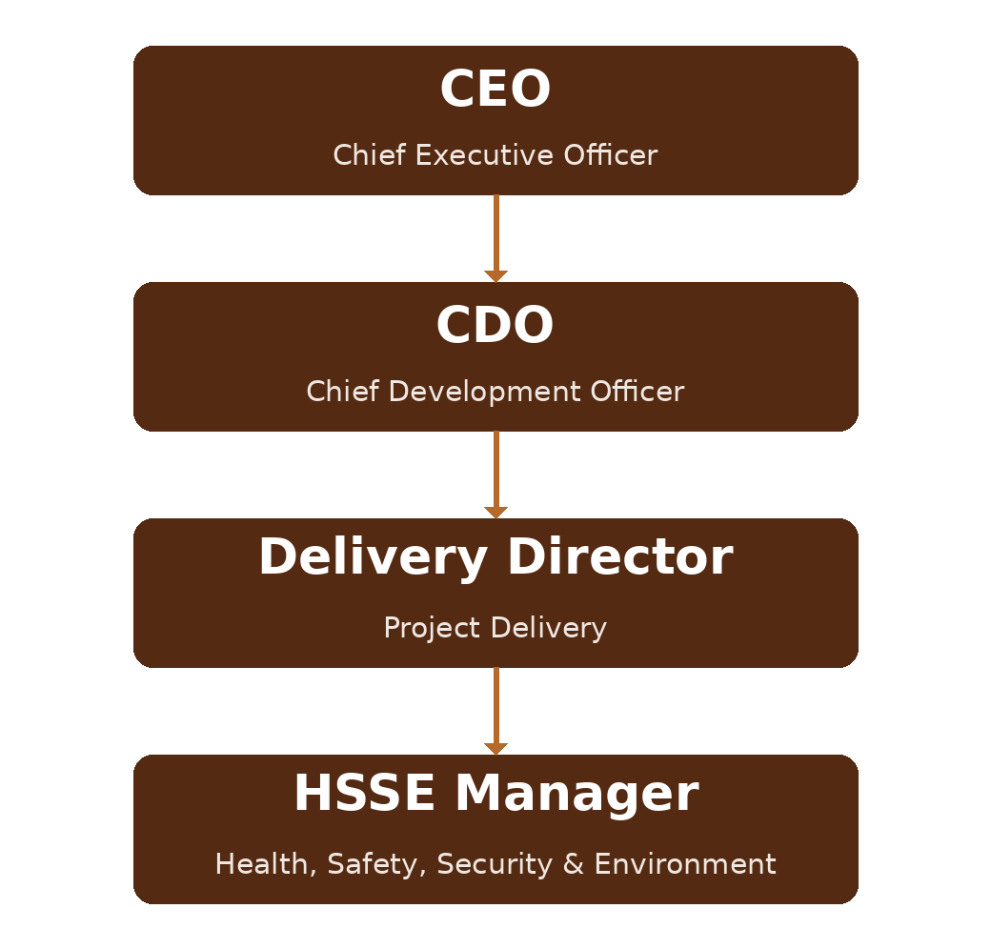
Figure 1 DAN Corporate Organisation Chart
5.3.2 Project Structure
On each project, DAN (as Employer / Client) directs delivery through a Project Management Consultant (PMC), who manages and supervises the Contractor — and its subcontractors — executing the works. Each tier implements and is accountable for the DAN HSE Management System within its scope.
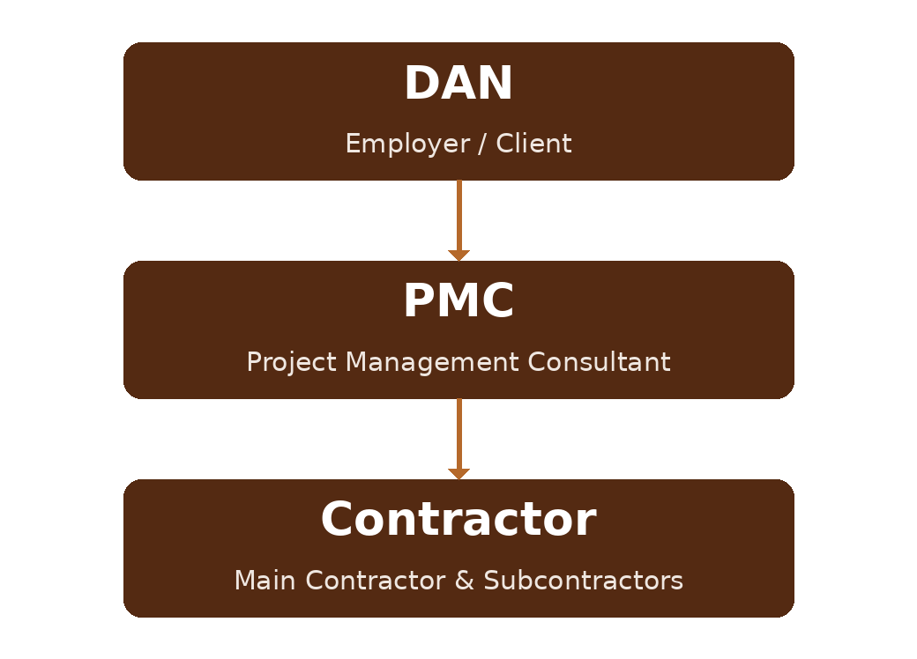
Figure 2 Project Structure
5.3.3 DAN (Employer / Client)
DAN, led by the HSSE Manager under the Delivery Director, holds overarching responsibility for HSE across its projects and shall:
- Set the programme-wide HSE Management System, Policy, procedures and minimum requirements, and provide leadership, direction and resources for their implementation.
- Oversee full compliance of all parties with applicable national and international HSE legal requirements.
- Ensure the provision of sufficient, competent and medically fit resources for safe delivery, and appoint a PMC, contractors, designers and suppliers with the capability to deliver safely.
- Maintain and assure the HSE Management System through monitoring, inspection and audit, and drive corrective action and continual improvement.
- Review and approve project HSE plans and key submissions, and oversee the proper reporting, investigation and close-out of incidents to prevent recurrence.
- Suspend or stop work, at its discretion, where there is a serious or imminent threat to people, property or the environment.
5.3.4 Project Management Consultant (PMC)
The PMC manages and supervises delivery on DAN's behalf, adopting a zero-harm philosophy and providing HSE coverage of site activities at all times (day/night shifts and holidays). The PMC shall:
- Develop project/programme-specific HSE plans in line with the DAN HSE Management System and contractual obligations, subject to DAN approval.
- Ensure that the DAN HSE Management System — Manual, procedures and minimum requirements — and all applicable Saudi laws and regulations are followed by all parties on site.
- Review and approve the Contractor's RAMS, plans, permits, equipment certification and other HSE submissions, and ensure design risk information is communicated and managed.
- Establish and verify contractor competence and the allocation of adequate, competent HSE resources through formal interviews in line with DAN competency requirements.
- Monitor, supervise and measure contractor HSE performance; conduct inspections, audits and meetings; and report performance, KPIs and statistics to DAN.
- Ensure all reportable incidents are reported, thoroughly investigated and closed out per the DAN procedure and KSA legal requirements, and share lessons learned.
- Issue DAN-approved HSE enforcement notices and, in the event of a serious violation or imminent danger, suspend or stop the works until satisfactory corrective action is taken.
- Lead and record HSE campaigns and recognition, and ensure project HSE documentation is current.
5.3.5 Contractor and Subcontractors
The Contractor, acting as an employer, is fully liable and responsible for the areas under its work authority in accordance with the DAN HSE Management System, the DCSM procedures, the Saudi Labor Law and HSE legislation, and contract obligations. The Contractor shall:
- Develop and implement the project HSE plan, proactive monitoring programme (inspections, audits, fire drills, meetings), risk register, environmental aspects register and training/competency matrix, submitted for approval.
- Provide adequate numbers of competent, interviewed HSE staff in line with the required ratios (Clause 7.2), and competent supervisors for critical works (scaffolding/formwork, cranes and lifting, excavations, electrical, confined space, hot work).
- Ensure all persons are inducted and medically fit, and wear the minimum PPE (hard hat, safety footwear, eye protection, high-visibility clothing and, where required, face covering); PPE and health surveillance are determined by task-based risk assessment.
- Ensure all plant, lifting equipment and tackle are certified by a SASO-approved third party, maintained, and operated by competent persons.
- Report, investigate and record incidents per the DAN procedure and authorities' requirements; monitor and manage subcontractor compliance; and provide HSE reports and statistics.
- Provide and maintain compliant worker welfare facilities and accommodation, promote worker well-being (including mental health), and maintain site security so that only authorised persons and vehicles enter.
- Suspend work at its own discretion where there is a threat to HSE compliance or to the safety of persons, property or the environment.
Note: Where DAN delivers under an external Client/Consultant, or engages designers, DAN cooperates and coordinates so that design risk information, residual risks and the pre-construction information are communicated; designers apply the general principles of prevention and provide a Health and Safety File at handover.

5.4 Consultation and Participation of Workers
DAN consults and enables the participation of workers (and, where they exist, their representatives) at all applicable levels in the development, implementation, evaluation and improvement of the HSE Management System. Workers are involved in hazard identification, risk assessment, determining controls, incident investigation, and review of HSE performance. Consultation and participation are delivered through the HSE Committee, HSE meetings, tool-box talks, RAMS meetings and site briefings, and workers are given the time, training and information needed to participate without reprisal.

5.5 Reward and Recognition
Positive reinforcement motivates the workforce and drives a positive culture. DAN and its contractors operate a written HSE incentive/recognition scheme that recognises positive HSE behaviours at the individual and team level, focuses on leading indicators, and provides public recognition and awards for HSE excellence.

6. Planning

6.1 Actions to Address Risks and Opportunities
In planning the HSE Management System, DAN determines the risks and opportunities arising from its context (4.1), interested parties (4.2) and scope, considering: hazards; HSE risks and other risks; HSE opportunities and other opportunities; and legal and other requirements. Risks, issues and controls are maintained in a Risk and Opportunities Register as documented information, and actions are integrated into the management system and monitored for effectiveness.
6.1.1 Hazard Identification and Assessment of Risks
DAN and its contractors establish, implement and maintain a process for the ongoing, proactive identification of hazards, taking account of: routine and non-routine activities; infrastructure, equipment, materials and substances; the physical conditions of the workplace; human factors and how work is done; design of work areas, processes and machinery; emergency situations; all people who may be affected (workers, contractors, visitors and the public); changes in the organisation, knowledge or information; past incidents; and how work is organised, including social and psychosocial factors such as workload, work hours, heat and leadership.
HSE risks from the identified hazards are assessed against applicable legal and other requirements and the effectiveness of existing controls, using the methodology and criteria defined in the Risk Management and Activity Hazard Analysis procedures (DCSM — SH&E Risk Management; Activity Hazard Analysis). The assessment is proactive, systematic and follows the hierarchy of controls, and the results are recorded in the project risk register and the RAMS.
6.1.2 Psychosocial / Psychological Health and Safety
DAN's responsibility for worker health includes protecting and promoting physical and psychological health and well-being. Psychosocial hazards — relating to how work is organised, social factors at work, and the work environment — are identified and managed consistently with other HSE risks, in line with recognised good practice on psychological health and safety at work, through the risk assessment process.
6.1.3 Environmental Aspects and Impacts
DAN and its contractors identify the environmental aspects of their activities, products and services that they can control or influence — including emissions to air, releases to land and water, energy and resource use, and waste — and assess their impacts to determine those that are significant. Significant aspects are controlled through the Construction Environmental Management Plan and the Waste Management procedure, and are recorded in an environmental aspects and impacts register.
6.1.4 Determination of Legal and Other Requirements
DAN establishes and maintains a process to identify, access, evaluate and maintain compliance with applicable HSE legal and other requirements. The principal KSA framework includes the Labor Law (Royal Decree M/51 and amendments) and the Occupational Health and Safety regulations issued by HRSD, the Civil Defence requirements for construction, the Saudi Building Code (SBC) and Saudi Fire Code (SBC 801), GOSI social-insurance obligations, and SASO standards, together with applicable environmental regulations.
Under the Labor Law, the employer shall take the necessary precautions to protect workers against hazards and occupational disease at no cost to the worker, including (among others): maintaining a clean and hygienic worksite with adequate lighting, drinking and washing water and appropriate toilets; posting safety instructions in Arabic and other languages understood by the workforce; informing workers of the hazards of their jobs and providing and training them in PPE; providing fire-fighting means and safe exits; providing first-aid cabinets and, for larger sites, a paramedic, first-aid room and (where remote) an ambulance; and providing periodic medical check-ups and health surveillance. Construction companies fall within the higher-obligation employer group and shall provide HSE officers in line with the prescribed ratios (see Clause 7.2).

6.2 HSE Objectives and Planning to Achieve Them
6.2.1 Zero-Harm Philosophy and Objectives
DAN's Zero-Harm philosophy commits everyone engaged on DAN projects to effectively reduce the risks from our activities so that all personnel return home safely. Our goal is that our activities result in:
- Zero fatalities.
- Zero permanently disabling injuries.
- Zero injuries to members of the public.
- Zero long-term harm to health.
- Zero significant environmental incidents.
HSE objectives are established at relevant functions and levels, are measurable and monitored, consistent with the HSE Policy, and supported by plans that define what will be done, the resources required, who is responsible, when it will be completed and how results will be evaluated (including leading and lagging KPIs).
6.2.2 Strategic Elements
The HSE strategy rests on a set of equally important elements that underpin the management system and against which performance is benchmarked through KPIs: leadership and accountability; risk assessment and management; competency and training; safe operations and asset integrity; contractor and supply-chain management; communications; emergency preparedness; incident reporting and analysis; community and off-the-job safety; and continual improvement — all supporting the Zero-Harm philosophy.

7. Support

7.1 Resources
DAN determines and provides the resources needed to establish, implement, maintain and continually improve the HSE Management System, including people, infrastructure, the work environment, and monitoring and measuring resources. Resource needs are determined by the HSE function (HSSE Manager) and approved by senior management.

7.2 Competence and Coverage
DAN ensures that workers are competent on the basis of appropriate education, training, skills and experience, sets and assesses competency levels, delivers HSE training and induction programmes, and appoints competent HSE personnel. As a minimum coverage requirement (or the local legal requirement, whichever is more stringent):
Tier | Minimum HSE coverage
DAN (project) | At least one competent HSE representative per project, scaled to project criticality and progress.
PMC | At least one HSE Manager per project, supported by HSE professionals at a minimum ratio of one per 200 workforce.
Contractor | At least one HSE Officer per 50 workers; every 10 officers led by an HSE Supervisor; a qualified HSE Manager appointed for each contract.
Critical works | Competent supervisors provided for scaffolding/formwork, cranes and lifting, excavations, electrical works, confined space and hot work.
In line with the KSA Saudization framework, construction employers (the higher-obligation group) appoint HSE officers at a ratio of one per 50 workers, up to an equivalent of 2% of the total workforce, with a phased Saudi-national requirement. The following table sets out the minimum HSE-officer establishment by workforce band (1:50 basis) and the indicative Saudi-national requirement at the 30%, 50% and 70% phasing levels, together with the professional/practitioner split:
Total workforce | HSE Officers (1:50) | Saudi @30% | Saudi @50% | Saudi @70% | Professionals (30–40%) | Practitioners (60–70%)
50–100 | 2 | 1 | 1 | 1 | 1 | 1
101–200 | 3 | 1 | 2 | 2 | 1 | 2
201–300 | 4 | 1 | 2 | 3 | 2 | 2
301–400 | 5 | 2 | 3 | 4 | 2 | 3
401–500 | 6 | 2 | 3 | 4 | 2 | 4
501–600 | 7 | 2 | 4 | 5 | 3 | 4
601–700 | 8 | 2 | 4 | 6 | 3 | 5
701–800 | 9 | 3 | 5 | 6 | 4 | 5
801–900 | 10 | 3 | 5 | 7 | 4 | 6
901–1,000 | 11 | 3 | 6 | 8 | 4 | 7
Note: The phased Saudi-national compliance dates apply by headcount band (e.g. 500+ and 200–499 employers at 30% from 1 Apr 2020, 50% from 1 Jan 2021 and 70% from 1 Jan 2022; 100–199 and 50–99 employers phased from 2020). Where local legislation introduces more stringent requirements, those take precedence.
HSE personnel hold qualifications, certification and professional membership appropriate to their level, as a minimum:
Position | Qualification / certification | Professional membership | Min. experience (years)
HSE Director | BSc Engineering / equivalent; NEBOSH Diploma or equivalent | Essential (e.g. IOSH/IIRSM) | 15–20 (8+ at Sr Manager)
Senior HSE Manager | BSc / equivalent; NEBOSH Diploma or equivalent | Essential | 10–15 (5+ at Manager)
HSE Manager | NEBOSH IGC + Construction certificate | Preferred | 8–10
HSE Engineer / Supervisor | NEBOSH IGC or equivalent | Optional | 5–8
HSE Officer | NEBOSH IGC or equivalent (preferred) | Optional | 2–5
Any change to HSE key personnel shall be notified in writing to DAN / the PMC within 48 hours.

7.3 Awareness
Workers are made aware of the HSE Policy and objectives; their contribution to the effectiveness of the system and the benefits of improved performance; the implications of not conforming; incidents and the outcomes of investigations relevant to them; and their right to remove themselves from situations they consider present an imminent and serious danger, with protection from undue consequences for doing so.

7.4 Communication
DAN determines the internal and external communications relevant to the HSE Management System — what, when, with whom and how to communicate — taking account of language and literacy so that information is understood by all workers (multilingual and pictorial where needed).
- Internal: regular information and meetings to raise awareness of HSE policies and standards, communicate developments and lessons learned, and support HSE campaigns, using transparent and open communication.
- External: meaningful, accurate and timely communication with external interested parties as required by regulation — including Civil Defence, HRSD, the Ministry of Health, the Ministry of Environment/Water/Agriculture, GOSI, SASO and the relevant authorities.

7.5 Documented Information
The HSE Management System is supported by documented information comprising the Manual, procedures, plans, forms, registers and records. Documented information is identified and described (title, date, reference, revision), reviewed and approved before issue, and controlled so that it is available and suitable for use, protected, distributed to the relevant functions, version-controlled, retained for defined periods, and that documents of external origin are identified and controlled, through DAN's document-control arrangements.

8. Operation

8.1 Operational Planning and Control
DAN plans, implements and controls the processes needed to meet HSE requirements by establishing operating criteria, implementing control of the processes in accordance with those criteria, and controlling planned changes and reviewing unintended changes. At construction level these controls are implemented through the DCSM procedure library, which is organised as follows:
- Governance and high-risk activities — General Requirements; Permit to Work; Confined Spaces; Hot Works; Lockout/Tagout; Electrical Safety; Excavations; Blasting.
- Work at height and access — Fall Protection; Scaffolding; Ladders; Walking/Working Surfaces; Aerial Lifts/MEWP; Steel Erection.
- Lifting and plant — Cranes and Hoists; Lifting, Rigging and Slings; Motor Vehicles and Equipment; Piling; Machine Guarding; Hand and Power Tools.
- Health, welfare and environment — PPE; Hazard Communication; COSHH; Manual Handling; First Aid; AED; Field and Office Facilities; Construction Environmental Management Plan; Waste Management; Painting and Coating; Compressed Gas Cylinders.
- Site control — Signage, Barrication and Traffic Control; Road Works; Night Work; Fire Protection and Prevention; Concrete and Masonry Construction; Remote/Lone Working.
- Management processes — Risk Management; Activity Hazard Analysis; Training; Pre-Construction Meeting; Monthly HSE Statistical Report; Accident/Incident Reporting and Investigation; Emergency Planning and Response.
8.1.1 Eliminating Hazards and Reducing Risks
Hazards are eliminated and risks reduced in accordance with the hierarchy of controls, in order of priority:
Order | Control
1 — Eliminate | Remove the hazard (e.g. design out, off-site fabrication).
2 — Substitute | Replace with a less hazardous process, material or equipment.
3 — Engineering | Isolate people from the hazard (guards, barriers, ventilation, re-organisation of work).
4 — Administrative | Change the way people work (procedures, permits, information, instruction, training, signage).
5 — PPE | Provide adequate personal protective equipment as the last line of defence.
8.1.2 Management of Change (MoC)
DAN establishes a process for the control of planned temporary and permanent changes that affect HSE performance — including changes to locations and surroundings, work organisation, working conditions, equipment, workforce, legal and other requirements, and knowledge or technology — and reviews the consequences of unintended changes, taking action to mitigate any adverse effects. Due diligence ensures changes do not introduce unforeseen hazards.
8.1.3 Procurement, Contractors and Award
HSE requirements are built into procurement and contractor management. Tenderers provide documented evidence of their HSE performance (management system and certification, qualified personnel, statistics, prosecutions/notices, medical facilities, hazard-identification and incident-analysis processes, training, audits, waste segregation/recycling and worker-accommodation arrangements). Before award, or before work commences, contractors submit a final, works-specific HSE plan at least four weeks in advance for evaluation. Plant and equipment are subject to a technical/engineering acceptance covering purpose, staff safety and competence, safe systems of work, risk assessments, maintenance, SASO-approved certification and warranties; equipment over ten years old is not procured for DAN works.

8.2 Emergency Preparedness and Response
DAN and its contractors establish, implement and maintain emergency preparedness and response arrangements (Emergency Response Plans) appropriate to each project, in accordance with the Emergency Planning and Response procedure. The arrangements assess potential emergencies, define a planned response and an incident command structure, provide trained responders and equipment, are periodically tested through drills with recorded outcomes and corrective actions, coordinate with external emergency services, and are reviewed and updated as required. A specific Inclement Weather Management procedure addresses summer/heat working, heavy rain, fog and flood, and high wind and storms.

9. Performance Evaluation

9.1 Monitoring, Measurement, Analysis and Evaluation
DAN establishes and maintains processes to monitor, measure, analyse and evaluate HSE performance and the effectiveness of controls, and to evaluate compliance with legal and other requirements. Leading and lagging indicators are tracked through weekly and monthly reports, statistics (including TRIR and LTIFR), incident reporting and investigation, and approved RAMS, with results used to identify trends and drive improvement. DAN expects an HSE performance and compliance level of 90% or above from contractors; shortfalls may lead to contractual consequences.
9.1.1 Evaluation through HSE Violations (RAG)
HSE violations across the high-risk categories (electrical, fire, work at height/scaffolding, confined space, slips/trips/falls, and people–plant interface) are observed, recorded and addressed using a traffic-light (Red-Amber-Green) status, with escalating consequences for sustained poor performance:
Status | Achievement | Action / consequence
Green | ≥ 90% | Good performance — maintain and proactively improve; no penalty.
Amber | 80–89% | Moderate — deficiencies highlighted, action plan required; notice escalating to graduated deductions if sustained.
Red | < 80% | Poor — significant risk; root-cause analysis and action plan required; warning letter escalating to monetary deduction.

9.2 Internal Audit
DAN plans and conducts periodic internal audits to provide assurance and drive improvement, verifying that the approved plans and procedures are implemented and that the system conforms to DAN's requirements and applicable legal requirements. Auditors are trained, competent and independent of the area audited; an audit programme defines the frequency, methods, responsibilities, scope and reporting, and results are reported to relevant management with corrective actions tracked to closure.

9.3 Management Review
Top Management reviews the HSE Management System at planned intervals (at least annually) to ensure its continuing suitability, adequacy and effectiveness. The review considers the status of actions from previous reviews, changes in internal/external issues and risks, performance against objectives and KPIs, incidents, audit results, compliance evaluation, consultation outcomes, and opportunities for improvement, and outputs decisions on improvement, changes to the system and resource needs.

10. Improvement

10.1 General
DAN determines opportunities for improvement and implements the actions necessary to achieve the intended outcomes of the HSE Management System, including improving HSE performance, promoting a positive culture and enhancing worker participation.

10.2 Incident, Nonconformity and Corrective Action
All incidents and nonconformities are reported, recorded, communicated, managed and investigated in a logical and consistent manner in accordance with the Accident/Incident Reporting and Investigation procedure; where local legislative requirements differ, the more stringent applies. DAN reacts in a timely manner to control and correct the nonconformity, deal with the consequences, and — with the participation of workers and relevant interested parties — determine and eliminate the cause(s) so that it does not recur, by reviewing and analysing the nonconformity, determining its causes, checking whether similar nonconformities exist, implementing corrective action in accordance with the hierarchy of controls and management of change, reviewing the effectiveness of the action, and updating risks, opportunities and the system as necessary. Corrective actions are appropriate to the significance of the effects, including environmental and psychological impacts.

10.3 Continual Improvement and Learning
The results of analysis and evaluation are used to drive continual improvement in HSE performance and in the suitability, adequacy and effectiveness of the management system. DAN commits to periodic reviews of HSE performance (including contractors and consultants), regular audits, embracing innovation, reporting and investigating incidents, and implementing action plans. DAN values the mixed skills, knowledge and experience of its workforce, encourages continual learning, and turns adverse events into shared lessons that improve future performance.

11. Reference Documents
- DAN HSE Policy (Clause 5.2)
- DAN Construction Safety Manual (DCSM) — HSE procedure library (01-000001-000000-DAN-HSE-PRC-000001 onwards)
- KSA Labor Law (Royal Decree M/51 and amendments) and HRSD Occupational Health & Safety regulations; Civil Defence requirements; Saudi Building Code (SBC) and Saudi Fire Code (SBC 801); GOSI; SASO standards
- Applicable KSA environmental regulations and the recognised high-level frameworks for occupational health & safety and environmental management

Revision History
Rev. | Date | Description of Change | Approved By
R00 | June 2026 | Initial issue. Restructured to the DAN integrated HSSE management-system template and re-branded in accordance with the DAN Brand Book. | Project Director
R01 | June 2026 | Re-coded to the updated DAN document-numbering convention (01-000001-000000-DAN-{discipline}-{type}-{seq}). | Project Director

